Instructions for Finding Emotions in Suicide Notes
Please print out these instructions as you may need to refer back to them later
Thank you for your help. This study is very important and you’re helping advance the science of suicide research. The official name of the study is “Analysis of Suicide Notes for Subjective Information” and it’s funded by the National Institutes of Health, National Library of Medicine. The person responsible is John Pestian, Ph.D.

Your role in this study will be to read at least 50 suicide notes and identify the emotions you find in those notes (we’ll explain how to do this in a minute). Once all the emotions are identified, a computer can use your work to learn to find those emotions in other text. With this research and others we are doing, we hope to find new ways to determine if someone might attempt or die by suicide.

The approximately 1,000 notes in the study have been sent in all from all over the country although they mainly come from Dr. Edwin Shneidman’s collection of notes. Dr. Shneidman was the father of the study of suicide and his work began when he uncovered a collection of notes in the Los Angeles Morgue in the 1940s.

The notes have been typed to look exactly as they were written, spelling errors, typos, and all. Some sentences won’t make sense. The names and addresses have been changed.

Before you begin, here are a few tips to help make the process easier for you:

- We recommend either the Firefox (http://www.mozilla.com/en-US/firefox/) or Safari (http://www.apple.com/safari/download/) browsers to access the web site.
- There is a video for you to watch that demonstrates the process of reviewing the notes. It is there to help you and we highly recommend you watch it before you begin.
- You are clicking each word in an entire sentence that refers to a specific emotion, NOT just a word or two.
- You are looking for emotions from the author’s perspective and it’s important that you don’t project your own emotions from your own experience into the sentences and emotions you click.
- Emotions might be scattered all over the text. DO NOT use these emotions. Focus on emotion that can be contained in a single sentence.
- Each emotion should be tied to an independent sentence. When it stands by itself, it should still represent the same emotion.
- If you find several independent sentences with the same emotion, mark them all red.

Here’s what you do:

First, you need to learn how to use the software. This will make the process much easier for you. To do this, you’ll be presented with a series of notes and asked to interpret them. You have three days to complete the training. Once you get comfortable with the note interpretation process, you will get access to the main system where you will have approximately 50 notes waiting for your review. You’re not working alone and some people may review the same notes as you. Please finish quickly so we can see if there are any differences to review and discuss.

You will be (described in the instructions below) reading through suicide notes and identifying the sentences that correlate with the list of emotions you will see on the right when you click on the notes. As you saw when you logged into the site, the page in front of you had a “Note List.” What’s important is the “Notes to Review” column on the right (Figure 1).
Figure 1
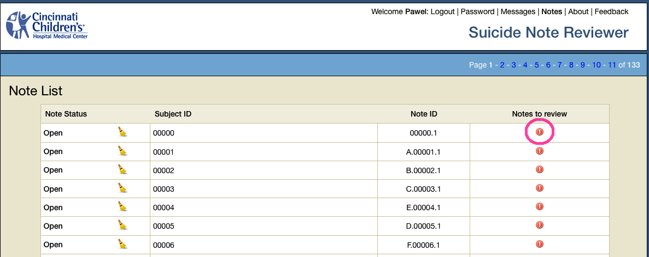
Click on “Notes to Review” and a suicide note will appear on the page in front of you. On the right you will see a list of emotions. If you run your cursor over the words, two examples of those words will appear. For each emotion, you will need to click on the emotion first and then click each word in the sentence in the suicide note that correlate with that emotion. Not all the emotions in the list will appear in each suicide note. Please mark the emotion that comes to mind first. We are only collecting information about basic emotions. Don’t spend too much time trying to interpret the author’s intention.

Figure 2

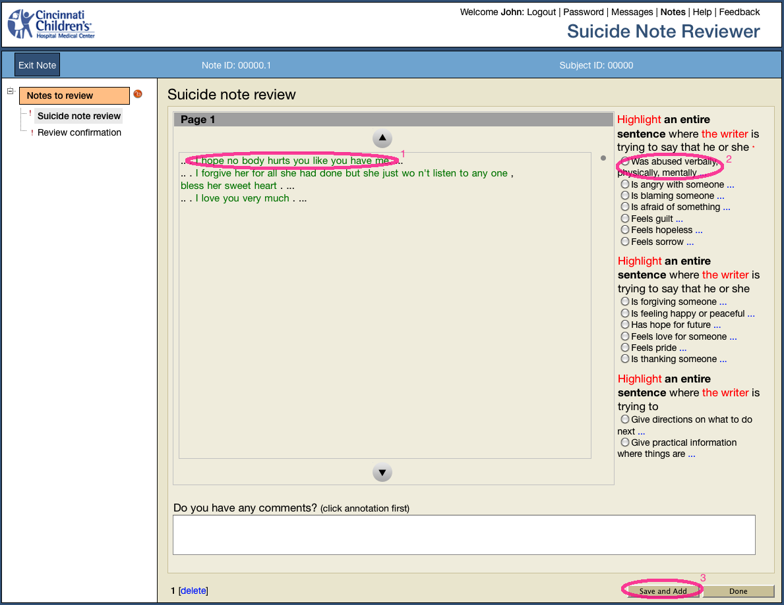

For each emotion that you find in the note, you will need to then click “Save and Add” at the bottom right corner (Figure 2). Each emotion will have its own page, as you will see at the bottom left. Each time you add an emotion and click on “Save and Add” a new page will be created– as shown at bottom of the Figure 3. Once you are finished, click “Done” and you will be asked if the note was easy or difficult to review. Then you click on “Save and Next” which will take you to the note list (Figure 1). If the note shows a green mark, that means it is locked and finished.
When you highlight the emotions, you’ll note that they turn to red on the current page. Previously annotated sentences will be blue (Figure 3).

Figure 3
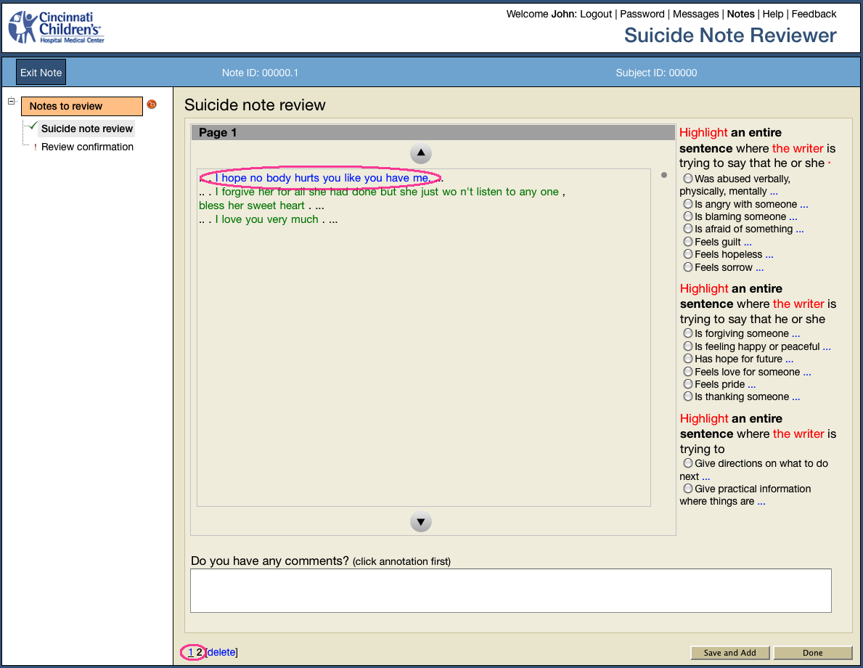
We need you to complete at least 50 suicide notes in five days (but you are welcome to do more). Michelle Linn-Gust, who is the manager of this portion of the study, will be in touch with you if there are any questions about how you identified any of the emotions or if there is disagreement between how you and others have identified them.
Note review correction
If you would like to delete an emotion, click on “delete” at the bottom left of the screen. You will see the number associated with that emotion is no longer underlined and that means that emotion was deleted from that page (Figure 4). If the review of the note has been completed, as shown by a green icon, then click the icon to edit the note.

Figure 4
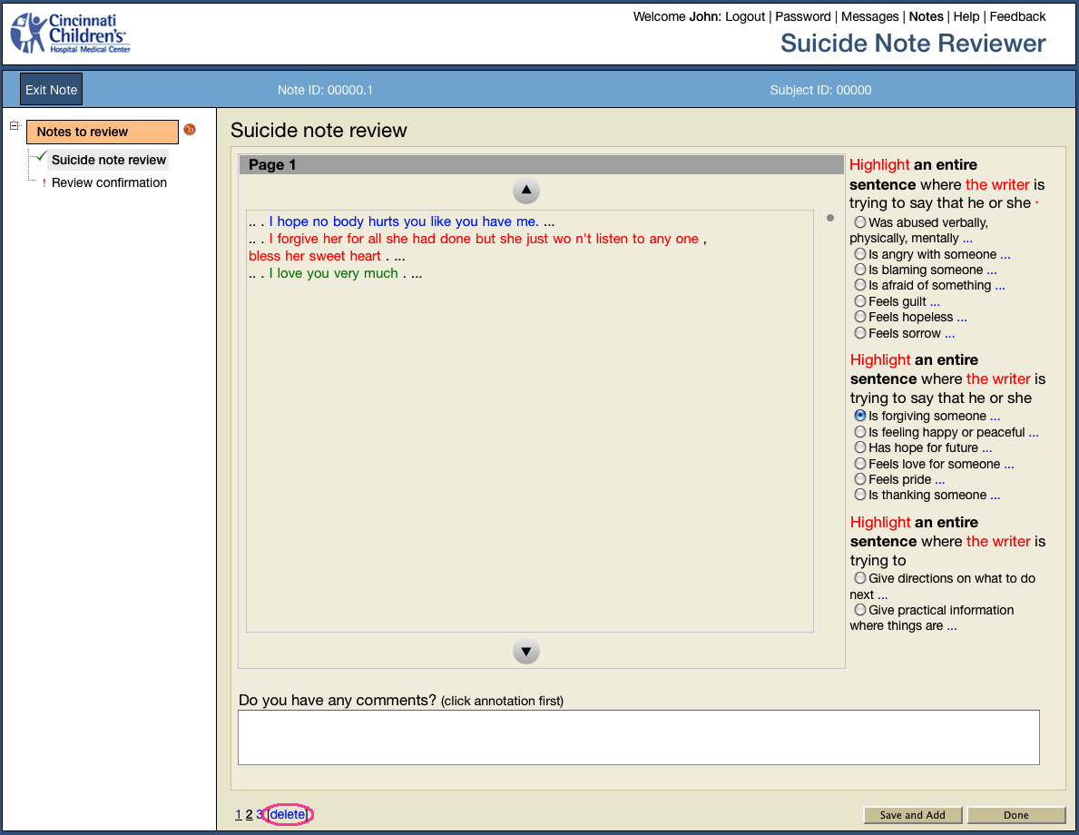
Likewise, feel free to contact Michelle if you have questions and comments about any of the notes and what you see or if you’re having any issues analyzing them.
Note review comments
To contact Michelle while reviewing a note, click on the emotion you have a question about and then go to the bottom of the page, and click inside the white box. A string of words will pop up and then you can leave your message after them. Be sure to click “Save and Add” or the message will not be sent to her (Figure 5). Whenever you see a blue envelope (Figure 6) it means that Michelle has left a comment for you about your annotation. Click on the envelope, read the message, correct your annotation (if necessary), and you can leave a comment for Michelle below the annotation box that you have taken care of it (Figure 7).

Your own comments turn your annotation dark yellow (Figure 5). While Michelle comments turn your annotation pink (Figure 7). You can get to message shortcuts by clicking “Messages” link in top right corner (Figure 6).

Figure 5

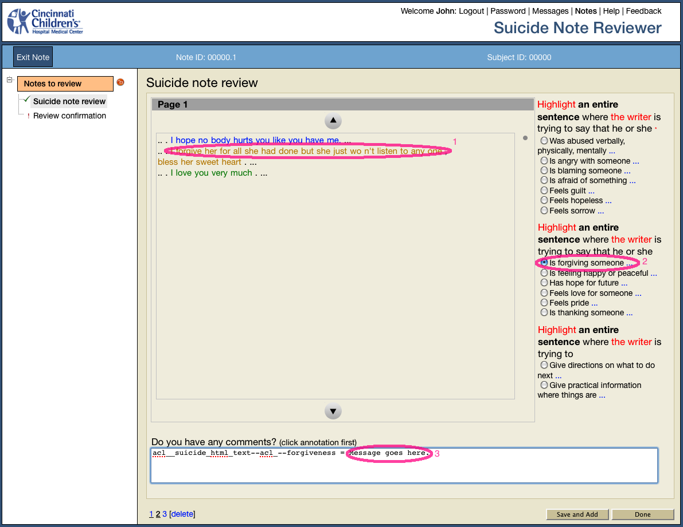

Figure 6

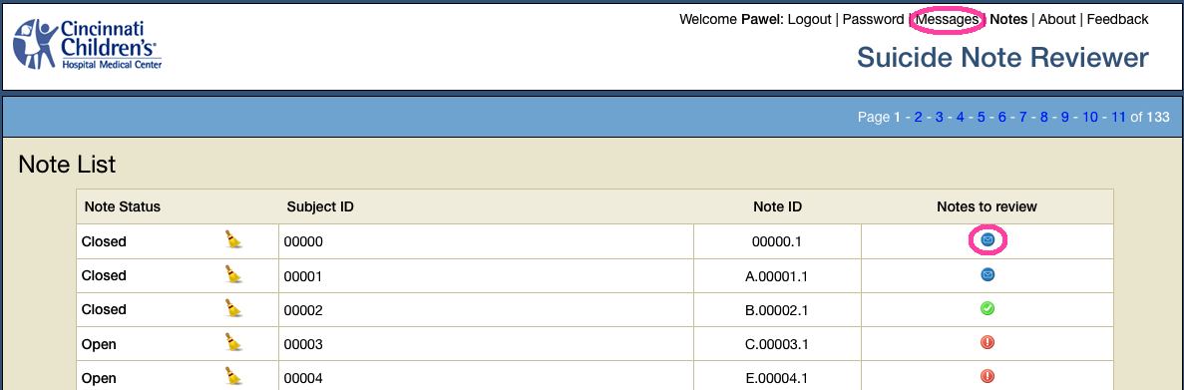

Figure 7

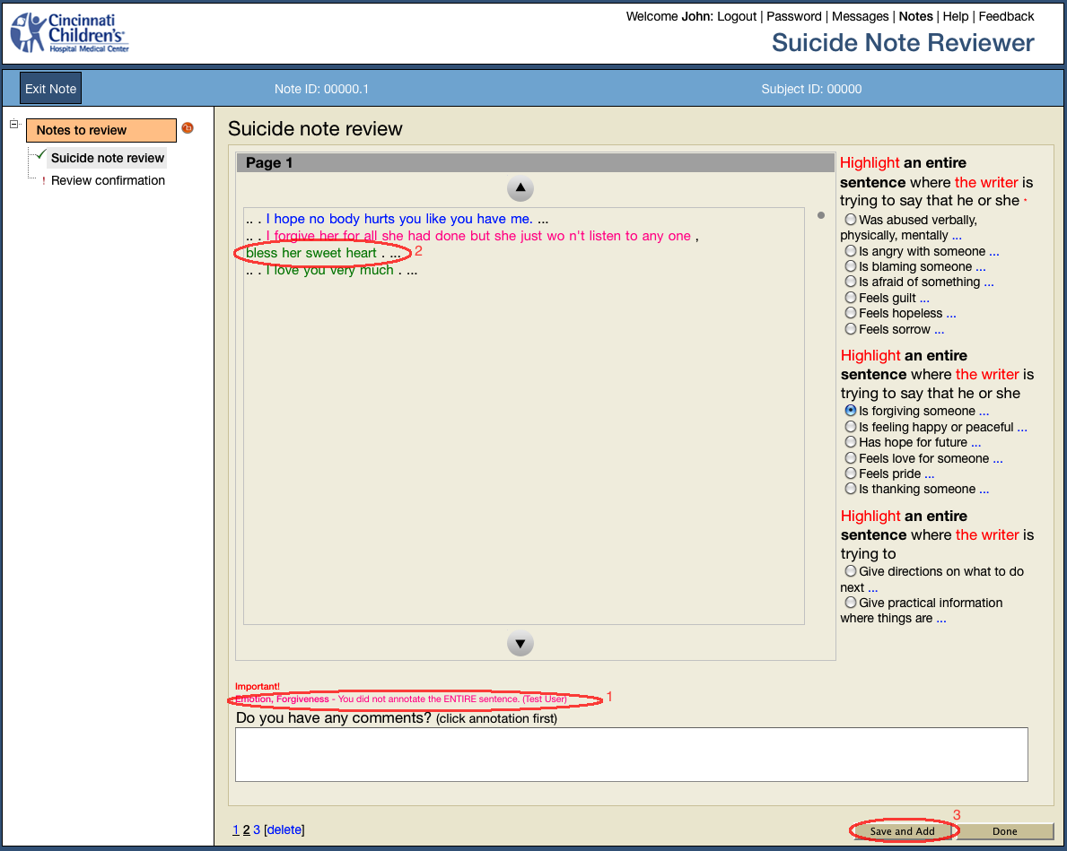

Thank you
Again, thank you for taking part in this very important study. People who have lost loved ones to suicide, sometimes called survivors of suicide or the bereaved by suicide, have been selected to help identify these emotions because of the losses they have incurred. You are one of these people and we understand your desire to help others, to ensure that no other family endures what yours has, and that people who are suicidal find a road to hope again. This study is one way you are giving back and helping others find hope and meaning to life.
If at any point during the annotation process you need emotional support, please call the National Suicide Prevention Lifeline at 1-800-273-8255. There is support 24 hours a day available to you.

